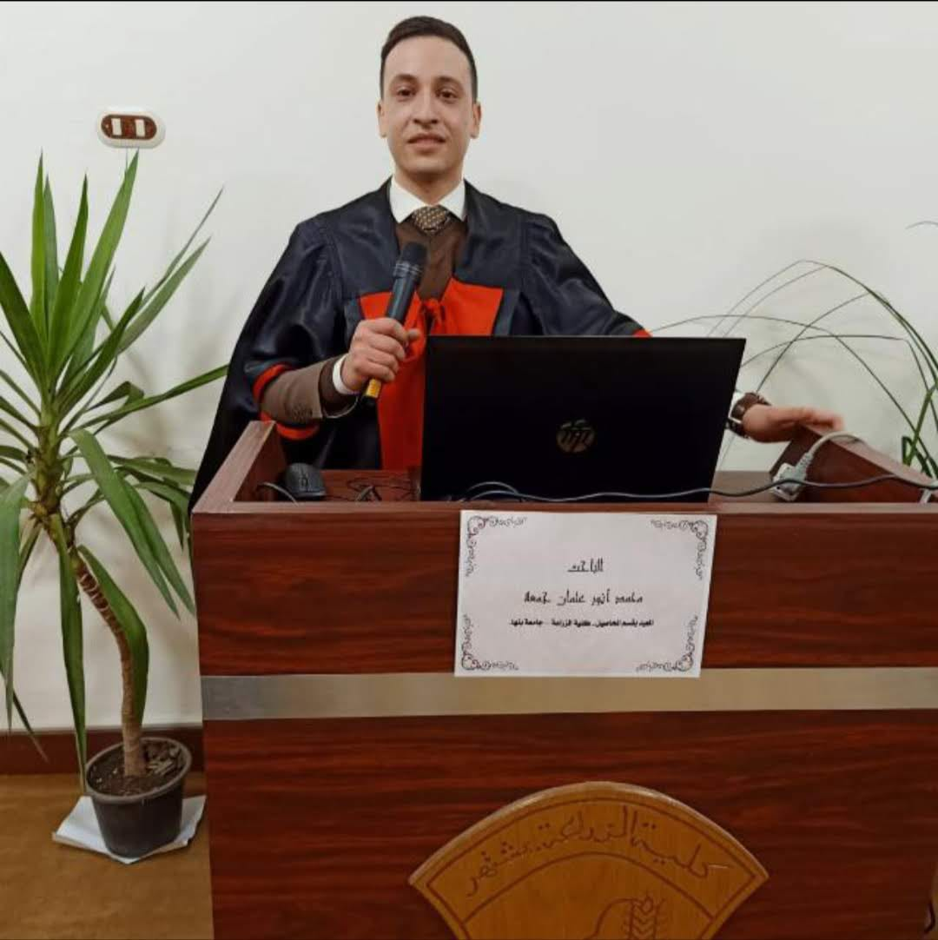

Curriculum Vitae
Name: Mohamed Anwar Osman
Position: Assistant Lecturer, Department of Agronomy, Faculty of Agriculture, Moshtohor – Benha University
Date of Birth: 19 May 1993
Place of Birth: El-Genina, Meniet El-Nasr, Dakahlia Governorate, Egypt
National ID Number: 29305191200378
Nationality: Egyptian
Address: Faculty of Agriculture – Moshtohor, Toukh, Qalyubia, Egypt
Postal Code: 13736
Landline Phone: +20 13 2464068
Mobile Phone: +20 1030116609
Email: mohamed.anwar@fagr.bu.edu.eg

Field of Specialization
* General Specialization: Crop Production
* Specific Specialization: Forage and Range Crops

Academic Qualifications
* B.Sc. in Agricultural Sciences (Agronomy), Faculty of Agriculture, Benha University – 2015
* M.Sc. in Agricultural Sciences (Agronomy), Faculty of Agriculture, Benha University – 2021

Published Scientific Research
1.
Title: Quantitative and qualitative evaluation of successive annual forage crops in all patterns of some summer and winter forage grasses under different fertilization levels
Reference:
M. A. Osman, A. M. S. Ibrahim, H. M. M. El-Naggar, and S. A. Seif
Annals of Agricultural Science, Moshtohor, Vol. 60(1), 2022: 9–24
2.
Title: Quantitative and qualitative evaluation of non-traditional forages of Conocarpus trees with Saligna, Atriplex, and Adhatoda shrubs under (NPK) fertilization levels
Reference:
M. A. Osman, A. M. S. Ibrahim, H. M. M. El-Naggar, and S. A. Seif
Annals of Agricultural Science, Moshtohor, Vol. 60(3), 2022: 763–778
3.
Title: Assessment of fertilization levels, plant densities, and cladode planting direction on Opuntia ficus-indica as a non-traditional forage source
Reference:
M. A. Osman, A. M. S. Ibrahim, H. M. M. El-Naggar, and S. A. Seif
World Journal of Agricultural Sciences, Vol. 17(6), 2021: 491–508

